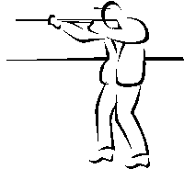
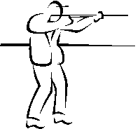

HGS SKEET SHOOT

Saturday, June 10, 2017
Greater Houston Gun Club
6702 McHard Road, Missouri City

This tournament is a 50 target event. Shells are provided, however you must bring eye and ear protection. Greater Houston Gun Club and National Skeet Shooting Association safety rules will be in effect. Trophy winning shooters will be determined by the Lewis class system. Door prizes will be awarded by blind drawing after the conclusion of shooting. All competitors are automatically entered into the door prize drawing, but you must be present at the time of the drawing to win. BBQ lunch will be provided from 11:30 until 1:30. Refreshments will be available throughout the day. Non-shooting guests are welcome to enjoy lunch and refreshments at a cost of $20 per guest.

HGS recognizes that 2017 is a lean year in the oil patch, and sponsorship for events like this is hard to find. For $150, you’ll receive paid entry for one shooter and one guest (total value of $120) and be listed as a platinum sponsor on the webpage and at the event.
We are limited to 160 shooters in four rotations. Entry fee is $90 per shooter for registrations received by FRIDAY, JUNE 03. After June 03, registration will be strictly on a “space available” basis and the entry fee will be $120 per shooter. Register early!!

For more information, contact: Gready Hunter at (281) 384-9035 or greadyhunter@comcast.net

For directions to the club, visit www.greaterhoustongunclub.com
*************************************************************************************

ONLINE REGISTRATION INFORMATION AT: www.hgs.org/civicrm/event/info?id=1643
To pay by check, mail this form with a check made out to HGS to:
Houston Geological Society, 14811 St. Mary’s Lane, Ste. 250, Houston, TX 77079
To pay by credit card, please call the HGS office: (713) 463-9476.

Name: ____________________________________ Company: _____________________

Email: ____________________________________ Phone: ________________________

Preferred time: (circle one) 9:00 10:00 11:00 12:00 Ammo: (circle one) 12 gauge 20 gauge

Entry Fees: $ _____ + Guest Fees: $_____ + Sponsor Contribution: $ _____ = Total: $______

If you wish to register as a squad, please return forms for all squad members together.

ALL SHOOTERS WILL BE REQUIRED TO SIGN A DISCLAIMER OF RESPONSIBILTY BEFORE THEY WILL BE ALLOWED TO SHOOT!

